**TASK # 1: Write a script that tests as many of the Math library functions in section 1 as you can. Exercise each**

**of these functions by having your program display tables of return values for several argument**

**values in an HTML5 textarea**

**code:**

<!DOCTYPE html>

<html>

<head>

<title></title>

<meta charset="utf-8" />

<link href="styles.css" rel="stylesheet" />

</head>

<body>

<div class="main">

<input placeholder="enter number 1" type="text" id="num1" name="num1" />

<input placeholder="enter number 2" type="text" id="num2" name="num2" />

<input placeholder="Result" type="text" id="result" name="result" readonly />

<p>

<button id="divide" name="divide" onclick="divide(document.getElementById('num1').value, document.getElementById('num2').value)">Divide</button>

</p>

<p>

<button id="multiply" name="multiply" onclick="multiply(document.getElementById('num1').value, document.getElementById('num2').value)">Multiply</button>

</p>

<p>

<button id="add" name="add" onclick="add(document.getElementById('num1').value, document.getElementById('num2').value)">Add</button>

</p>

<p>

<button id="subtract" name="subtract" onclick="subtract(document.getElementById('num1').value, document.getElementById('num2').value)">Subtract</button>

</p>

<p>

<button id="sqroot" name="sqroot" onclick="squareRoot(document.getElementById('num1').value)">squareroot</button>

</p>

<p>

<button id="log" name="log" onclick="log(document.getElementById('num1').value)">Log</button>

</p>

<p>

<button id="power" name="power" onclick="power(document.getElementById('num1').value,document.getElementById('num2').value)">power</button>

</p>

<p>

<button id="sin" name="sin" onclick="sin(document.getElementById('num1').value)">sin</button>

</p>

<p>

<button id="cos" name="cos" onclick="cos(document.getElementById('num1').value)">cos</button>

</p>

<p>

<button id="tan" name="tan" onclick="tan(document.getElementById('num1').value)">tan</button>

</p>

</div>

<script>

function log(num1) {

num1 = parseFloat(num1);

var result = Math.log(num1);

document.getElementById('result').value = result;

}

function power(num1,num2) {

num1 = parseFloat(num1);

var result = Math.pow(num1,num2);

document.getElementById('result').value = result;

}

function sin(num1) {

num1 = parseFloat(num1);

num1 = num1 / 57.28;

var result = Math.sin(num1);

document.getElementById('result').value = result;

}

function cos(num1) {

num1 = parseFloat(num1);

num1 = num1 / 57.28;

var result = Math.cos(nrum1);

document.getElementById('result').value = result;

}

function tan(num1) {

num1 = parseFloat(num1);

num1 = num1 / 57.28;

var result = Math.tan(num1);

document.getElementById('result').value = result;

}

function squareRoot(num1){

num1 = parseInt(num1);

var result = Math.sqrt(num1);

document.getElementById('result').value = result;

}

function divide(num1, num2) {

num1 = parseFloat(num1);

num2 = parseFloat(num2);

var res = num1 / num2;

document.getElementById('result').value = res;

}

function multiply(num1, num2) {

num1 = parseFloat(num1);

num2 = parseFloat(num2);

var res = num1 * num2;

document.getElementById('result').value = res;

}

function add(num1, num2) {

num1 = parseFloat(num1);

num2 = parseFloat(num2);

var res = num1 + num2;

document.getElementById('result').value = res;

}

function subtract(num1, num2) {

num1 = parseFloat(num1);

num2 = parseFloat(num2);

var res = num1 - num2;

document.getElementById('result').value = res;

}

</script>

</body>

</html>

**Output:**

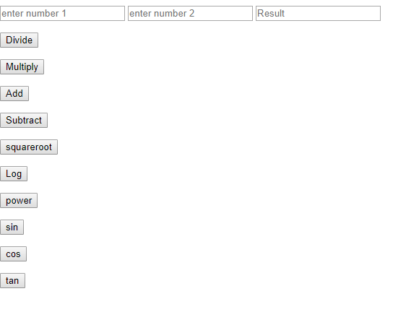

**Task # 2 : Math method floor may be used to round a number to a specific decimal place. For example,**

**the statement**

**y = Math.floor( x * 10 + .5 ) / 10;**

**rounds x to the tenths position (the first position to the right of the decimal point). The statement**

**y = Math.floor( x * 100 + .5 ) / 100;**

**rounds x to the hundredths position (i.e., the second position to the right of the decimal point).**

**Write a script that defines four functions to round a number x in various ways:**

**a) roundToInteger( number )**

**b) roundToTenths( number )**

**c) roundToHundredths( number )**

**d) roundToThousandths( number )**

**For each value read, your program should display the original value, the number rounded to the**

**nearest integer, the number rounded to the nearest tenth, the number rounded to the nearest**

**hundredth and the number rounded to the nearest thousandth.**

**CODE :**

<!DOCTYPE html>

<html>

<head>

<title></title>

<meta charset="utf-8" />

</head>

<body>

<div class="main">

<p>

<input placeholder="enter number to round off" type="text" id="num1" name="num1" />

<button id="integer" onclick="roundToInteger(document.getElementById('num1').value)">Round to integer</button>

<button id="tenths" onclick="roundToTenths(document.getElementById('num1').value)">round to tenths</button>

<button id="hundredths" onclick="roundToHundredths(document.getElementById('num1').value)">round to hundreths</button>

<button id="thousandths" onclick="roundToThousandths(document.getElementById('num1').value)">Round to thousandths</button>

</p>

</div>

<script>

function roundToInteger(num1) {

num1 = parseFloat(num1);

result = Math.floor(num1);

document.getElementById('num1').value = result;

}

function roundToTenths(num1) {

num1 = parseFloat(num1);

result = Math.floor(num1 * 10 + .5) / 10;

document.getElementById('num1').value = result;

}

function roundToHundredths(num1) {

num1 = parseFloat(num1);

result = Math.floor(num1 * 100 + .5) / 100;

document.getElementById('num1').value = result;

}

function roundToThousandths(num1) {

num1 = parseFloat(num1);

result = Math.floor(num1 * 1000 + .5) / 1000;

document.getElementById('num1').value = result;

}

</script>

</body>

</html>

**OUTPUT:**

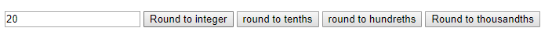

**TASK # 3: Write a script that uses relational and equality operators to compare two Strings input by the user**

**through an HTML5 form. Display whether the first string is less than, equal to or greater than the**

**second.**

**CODE :**

<!DOCTYPE html>

<html>

<head>

<title></title>

<meta charset="utf-8" />

</head>

<body>

<input type="text" id="string1" placeholder="string 1"/>

<input type="text" id="string2" placeholder="string 2" />

<input type="text" id="result" placeholder="result" />

<button onclick="compare(document.getElementById('string1').value,document.getElementById('string2').value)">Compare</button>

<script>

function compare(string1, string2) {

if (string1.length < string2.length) {

document.getElementById('result').value = "String 1 is smaller than string 2";

}

else if (string1.length > string2.length)

{

document.getElementById('result').value = "string 2 is smaller than string 1 ";

}

else {

document.getElementById('result').value = "Both are equal ";

}}

</script>

</body>

</html>

**OUTPUT:**

